Question : 1
Connect to a MySQL or PostgreSQL database using SQLAlchemy and pandas, then use pd.read_sql() to load the entire 'restaurants' table (imagine Zomato backend) into a DataFrame and display the first 5 rows :

import pandas as pd
from sqlalchemy import create_engine
engine = create_engine("mysql+pymysql://root:@localhost/mini_project")
df = pd.read_sql("SELECT * FROM restaurants_data", engine)
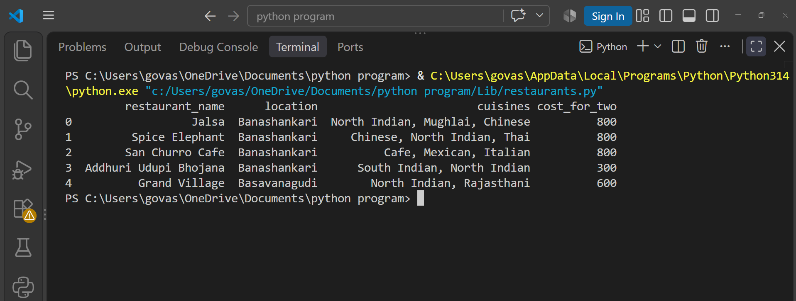
print(df.head())

Question : 2
Use pd.read_sql_query() to fetch only the 'name' and 'rating' columns from a 'movies' table (think BookMyShow-like data) where rating is above 8, and print the resulting DataFrame.<br><br><em><strong>Hint:</strong> Write a custom SQL SELECT query as the first argument to pd.read_sql_query() : </em>

import pandas as pd
from sqlalchemy import create_engine
engine = create_engine("mysql+pymysql://root:@localhost/mini_project")
query = """ SELECT name, rating FROM movies WHERE rating > 8 """
df = pd.read_sql_query(query,engine)
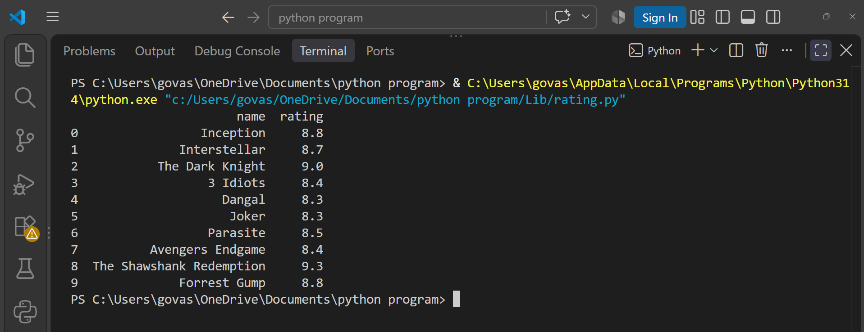
print(df)
Question : 3
Read a JSON dataset from the URL https://jsonplaceholder.typicode.com/users using pandas, convert it into a DataFrame, and print the usernames column.<br><br><em><strong>Hint:</strong> Use pd.read_json() directly with the URL : </em>

import pandas as pd
url = "https://jsonplaceholder.typicode.com/users"
df = pd.read_json(url)
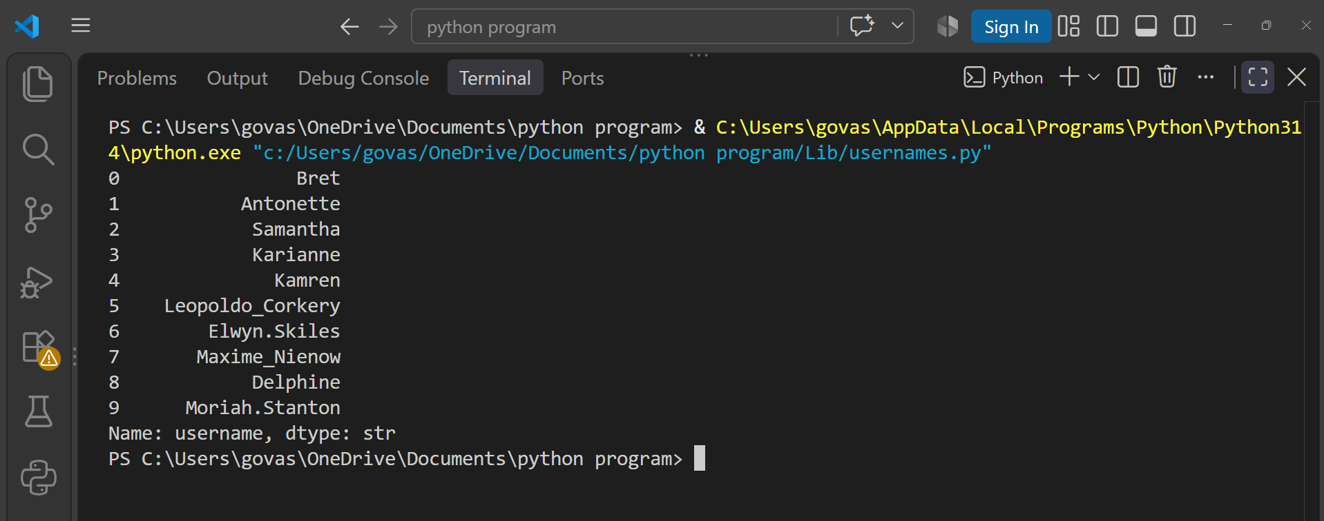
print(df["username"])

Question : 4
You have two CSV files: 'orders.csv' (order_id, user_id, amount) and 'users.csv' (user_id, username). Load both into DataFrames using pathlib for file paths, then merge them on 'user_id' to show a combined table with username and amount :

import pandas as pd
from pathlib import Path
orders_path = Path("Lib/orders.csv")
users_path = Path("Lib/users.csv")
orders = pd.read_csv(orders_path)
users = pd.read_csv(users_path)
combined = pd.merge(orders, users, on="user_id")
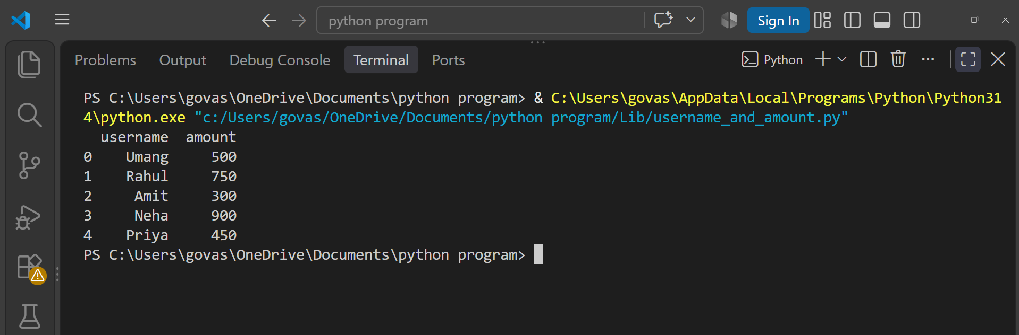
print(combined[["username", "amount"]])
Question : 5
Concatenate two DataFrames representing 'today_orders' and 'yesterday_orders' (each with columns: order_id, item, price), and display the combined DataFrame.<br><br><em><strong>Constraint:</strong> Use pd.concat() and reset the index after concatenation : </em>

import pandas as pd
today_orders = pd.DataFrame({
"order_id": [101, 102, 103],
"item": ["Pizza", "Burger", "Biryani"],
"price": [250, 180, 300]
})
yesterday_orders = pd.DataFrame({
"order_id": [98, 99, 100],
"item": ["Sandwich", "Pasta", "Dosa"],
"price": [150, 220, 120]
})
combined = pd.concat([today_orders, yesterday_orders])
combined.reset_index(drop=True, inplace=True)
print(combined)

